Management Control System

Software Training Materials

**Table of Contents**

1. INTRODUCTION OF MANAGEMENT CONTROL SYSTEM 3

How to Log in to the MCS 3

2. Administration Wing 3

# 1. INTRODUCTION OF MANAGEMENT CONTROL SYSTEM

……….

….

…….

…….

…….

The link for MCS is <http://192.168.3.7:3000/> which is accessible within BBA’s local network. After a search will open a login page. Which is like –

### How to Log in to the MCS

Figure : Log in Page

**Steps to Log in to MCS**

1. User will input his Username
2. User will input his Password
3. Click Log In Button

If the username & password are correct, users will get access to the system.

# 2. Administration Wing

For the Administration module –

**Steps to Enter in Administration**

1. After login will show this dashboard of MCS.

2. Click on Administration.

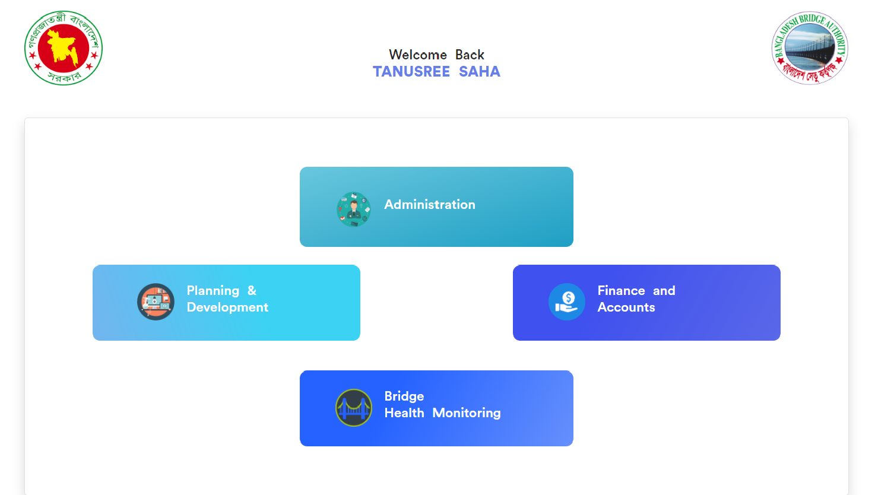

Figure 2: Dashboard of MCS

After entering into Administration will show another dashboard with another five (5) Submodules. Such as-

1. Human Resource
2. Estate
3. Transport
4. IT
5. Store

Figure 4: Dashboard of Administration Module.

1. **Administration >** **Human Resource**

* Click on Human Resource
* Will get another dashboard of Human resources with some menus.

There have 3 menus. Such as-

1. Dashboard
2. HR
3. Tipsoi

**Administration >** **Human Resource > Dashboard**

Click on Dashboard there has 2 sub-menus. These are-

1. Admin Dashboard
2. Employee Dashboard

**Administration >** **Human Resource > Dashboard > Admin Dashboard**

Here we can see all Employee’s information at a glance.

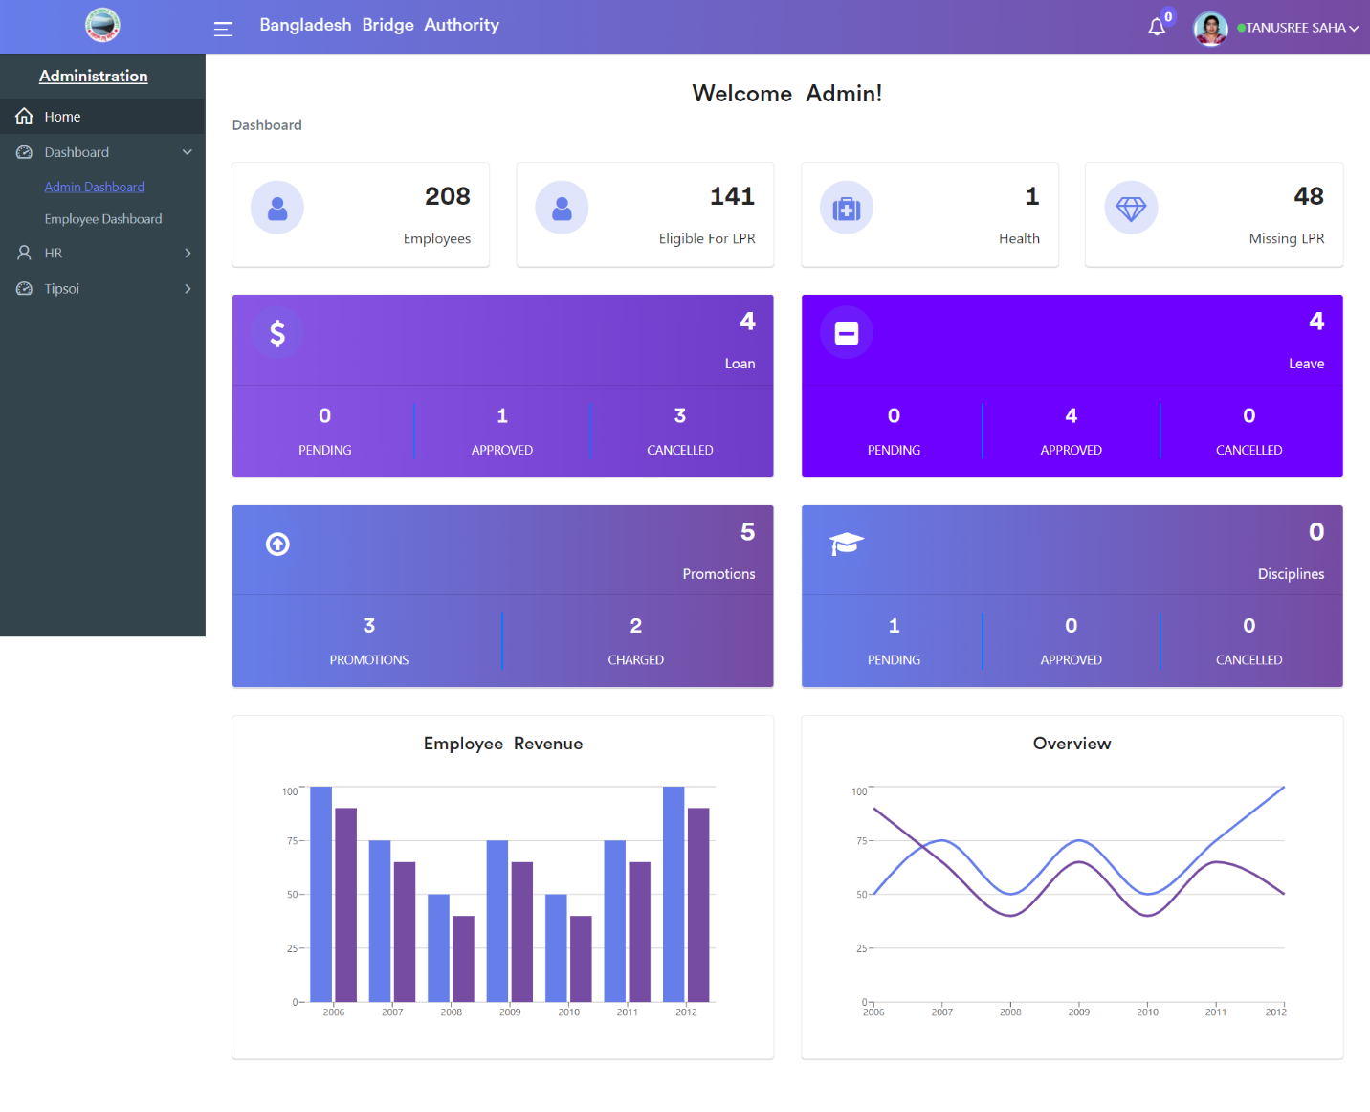

**Administration >** **Human Resource > Dashboard > Employee Dashboard**

Here we can see all Employee’s Loan, Leave, and Promotions information at a glance.

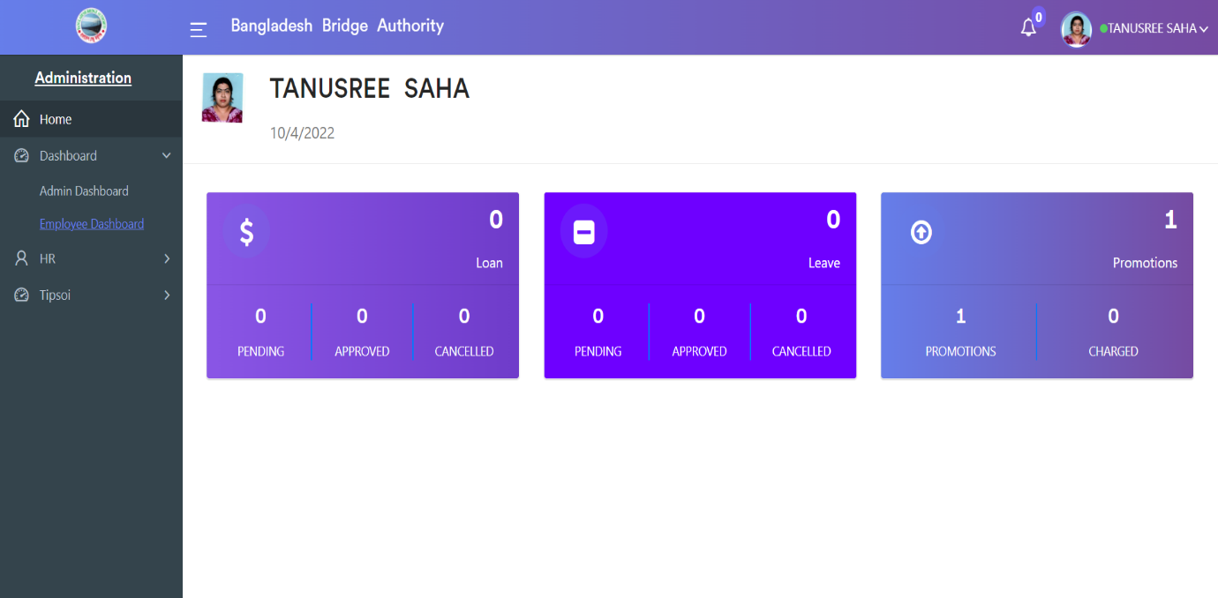

**Administration >** **Human Resource > HR**

Click on HR there has 7 sub-menus. These are-

1. Employees
2. Loan
3. Leave
4. Health
5. Discipline
6. Events
7. Settings

**Administration >** **Human Resource > HR > Employees**

After Clicking on Employees there has 5 sub-menus. These are-

1. All Employees
2. Education
3. Children
4. Promotion / Charge
5. Training

**1. All Employees:** After clicking on **Administration > Human Resource > HR > Employees > All Employees**. This employee module gives details about the employees working in the BBA and also about all the employee information.

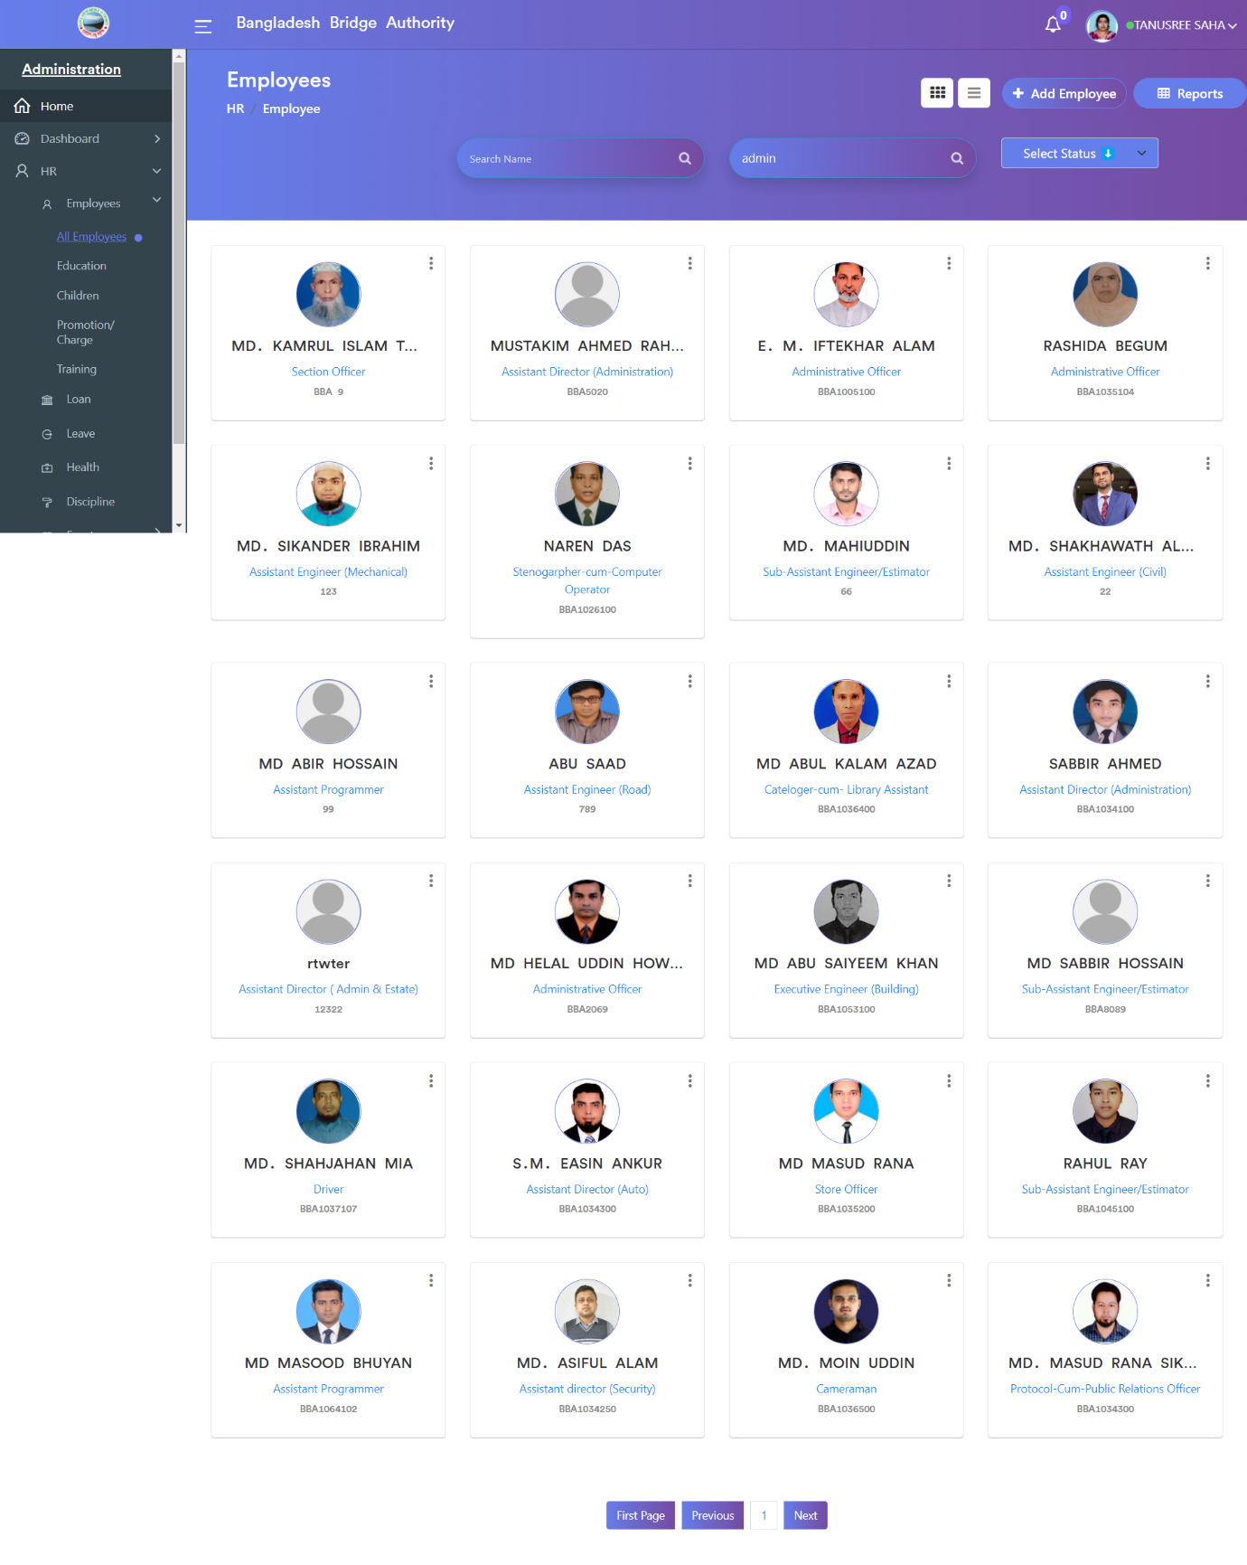

Click on the “Add Employee” button to create a new employee record. There we can add various information that is related to the employee. There have various pages clicking ‘Next’ we can enter the basic information such as the Employee details, Job details, General, Emergency contacts, etc.

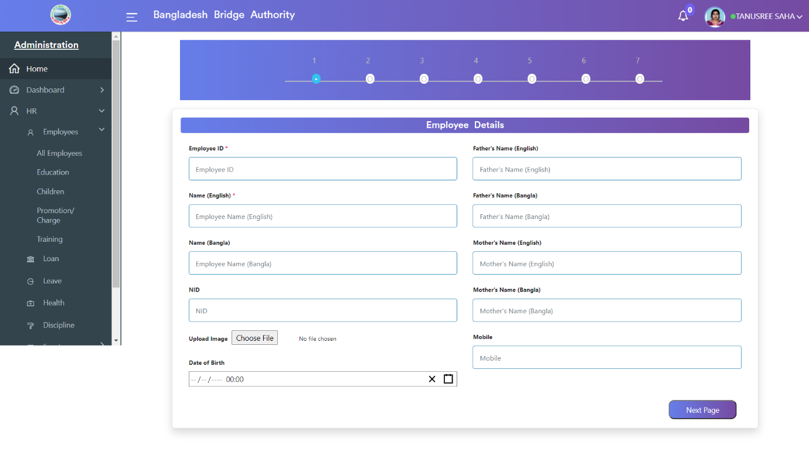

Click on the “Reports” button we can see all employee’s reports. Here we can download the employee’s record in Excel or PDF format.

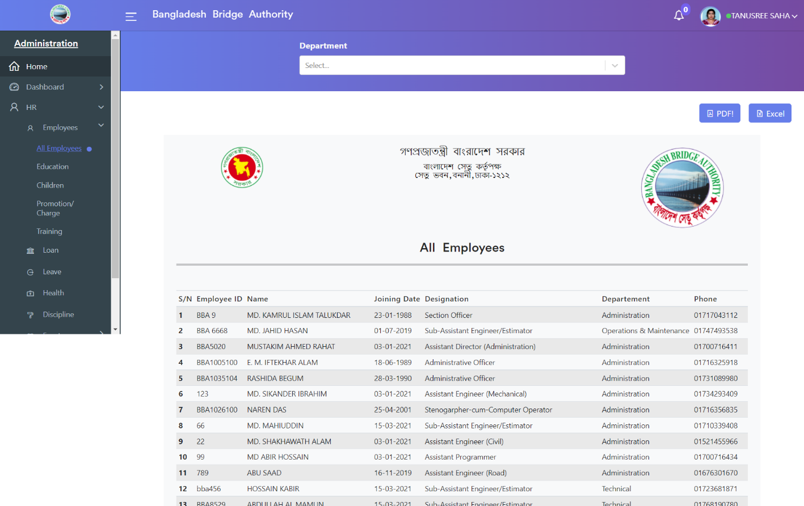

**2. Education:** After clicking on **Administration > Human Resource > HR > Employees > Education**. This module gives details about the employee’s educational information

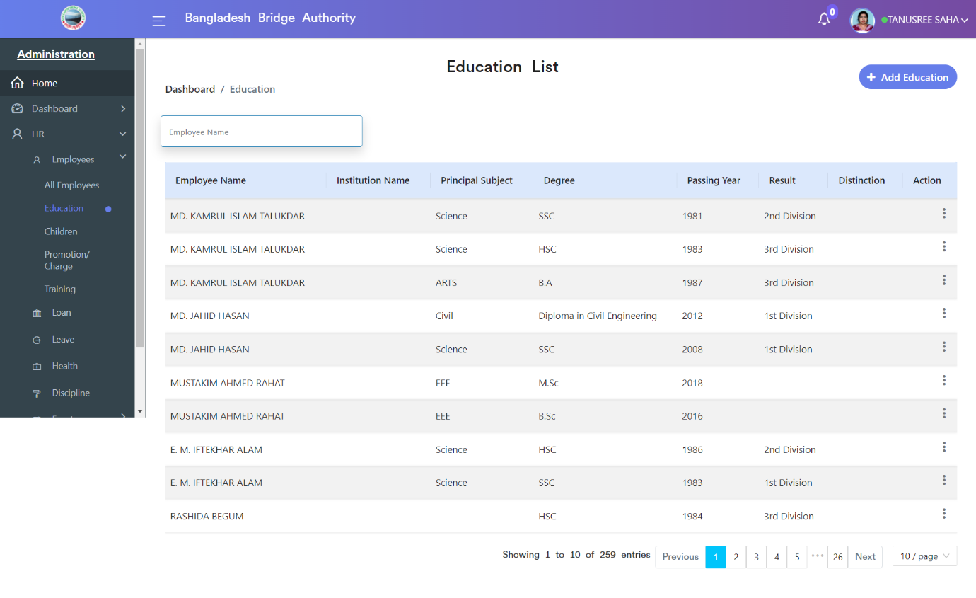

Click on the “Add Education” button to create a new employee educational record. There we can add various information that is related to the employee’s education.

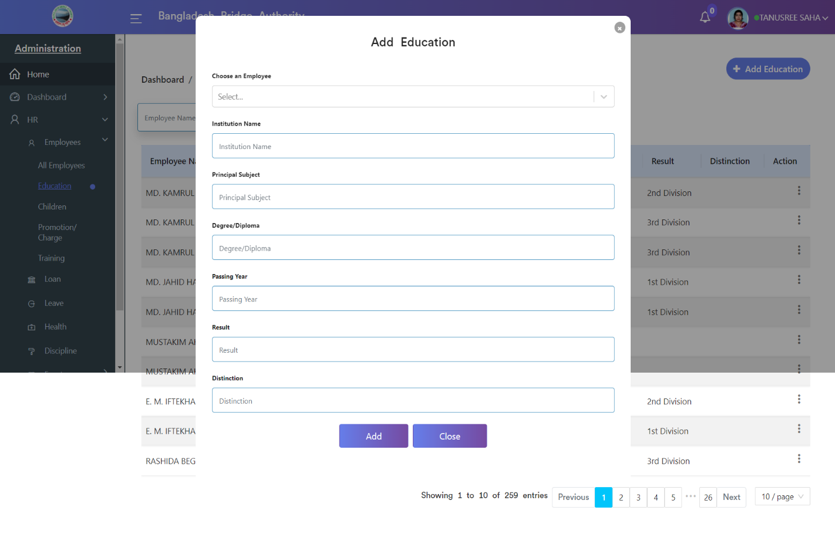

**3. Children:** Clicking on **Administration > Human Resource > HR > Employees > Children**. This module gives details about the employee’s children’s information.

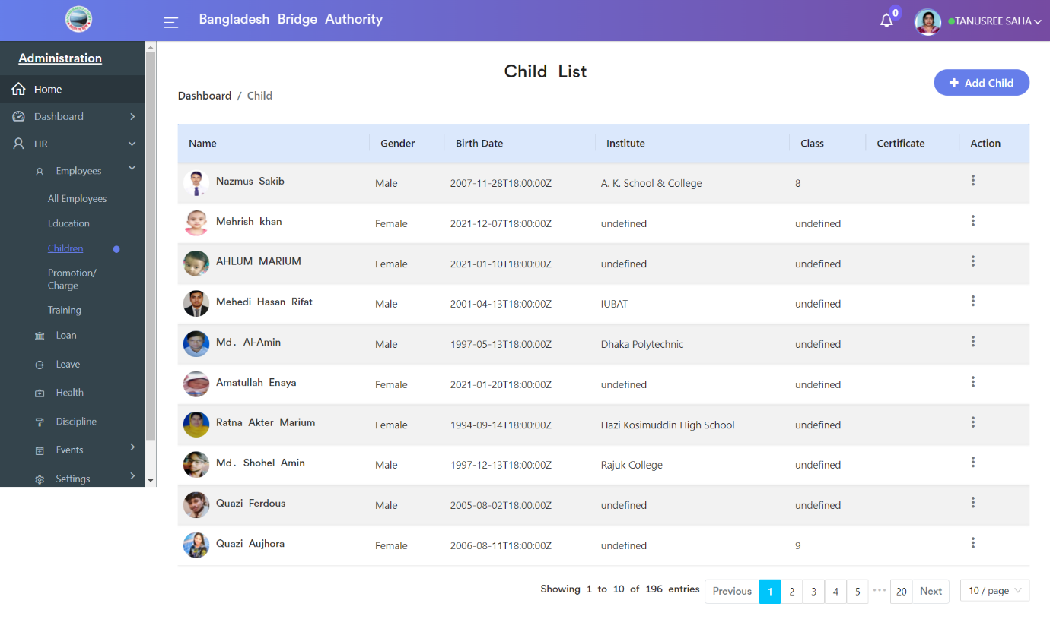

Click on the “Add Children” button to create a new employee children record. There we can add various information that is related to the employee’s children.

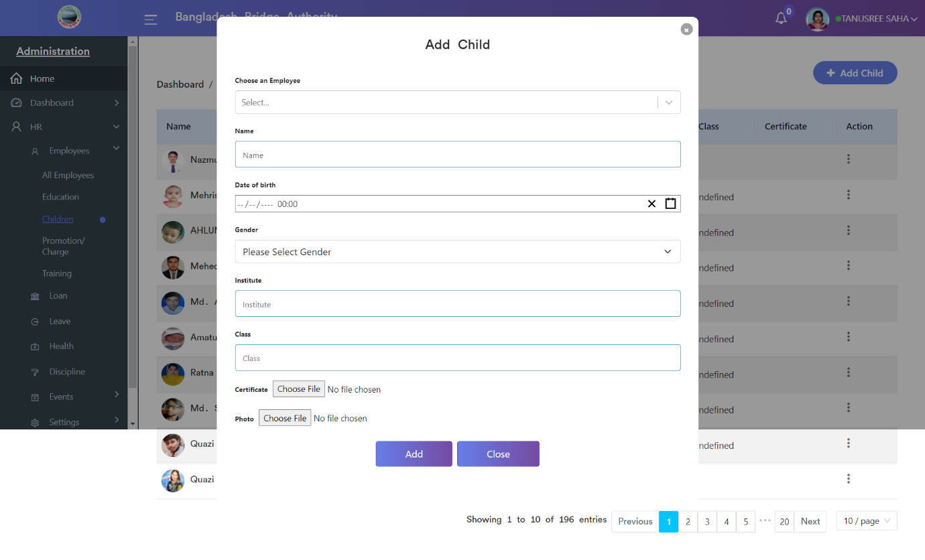

**4. Promotion / Charge:** Clicking on **Administration > Human Resource > HR > Employees > Promotion / Charge**. This module gives details about the employee’s promotion information.

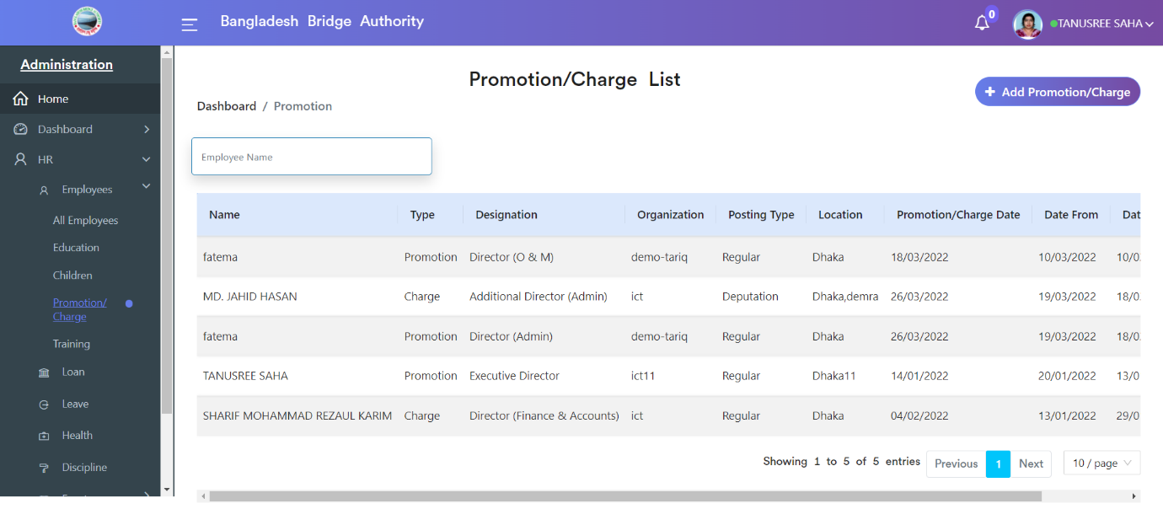

Click on the “Add Promotion/Charge” button to create a new employee Promotion/Charge record. There we can add various information that is related to the employee’s Promotion/Charge

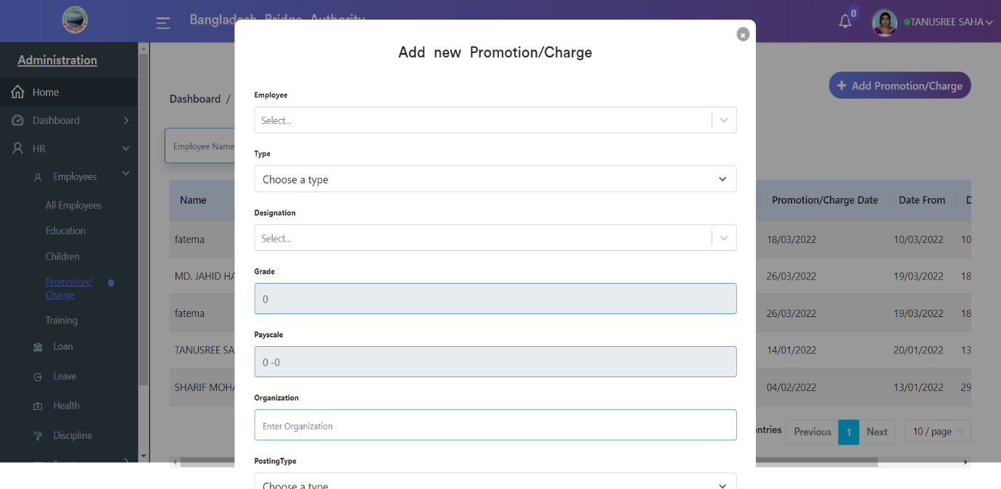.

**5. Training:** Clicking on **Administration > Human Resource > HR > Employees > Training**. This module gives details about the employee’s training information.

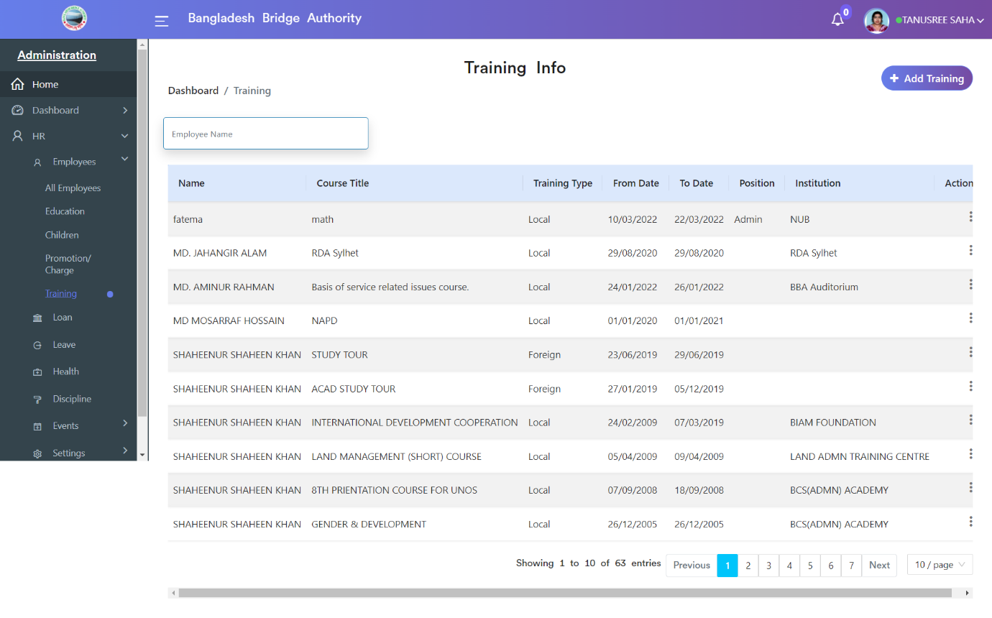

Click on the “Add Training” button to create an employee Training record. There we can add various information that is related to the employee’s Training.

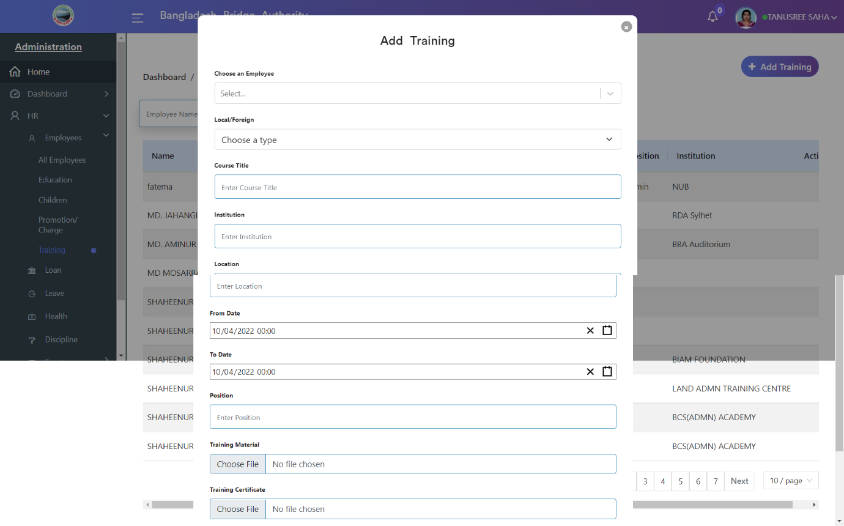

**Administration >** **Human Resource > HR > Loan**

Employees can apply for loans using the loan page with details such as loan amount, installment, sanction date, number of installments month, source of funds, etc.

Use the Employees > Loan > Employee Loan Request for Loans to see the list view of the Loan requests.

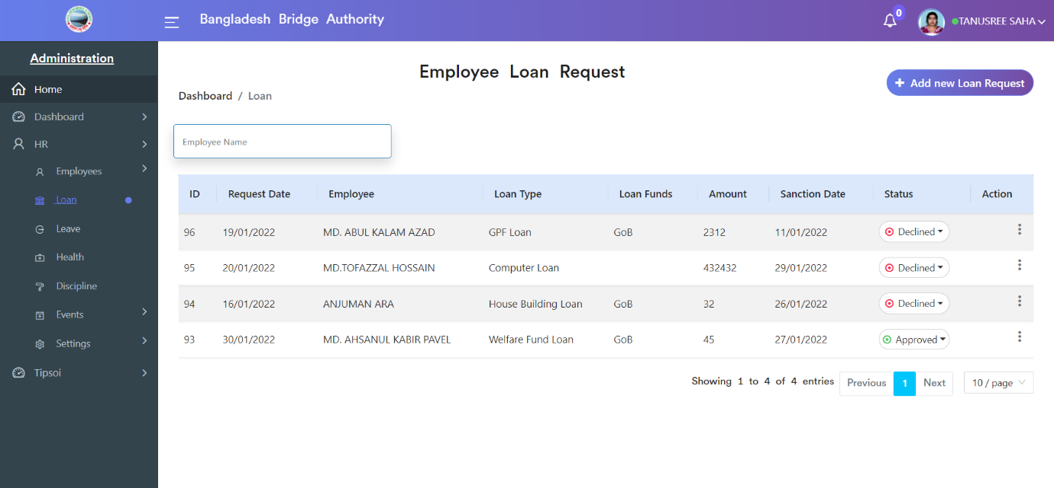

>> Click on the ‘Add new Loan Request’ button to create a new Loan request. Select the employee and fill in other details such as the loan amount, Loan Termination Date, etc. Then we can submit the request and wait for the approval.

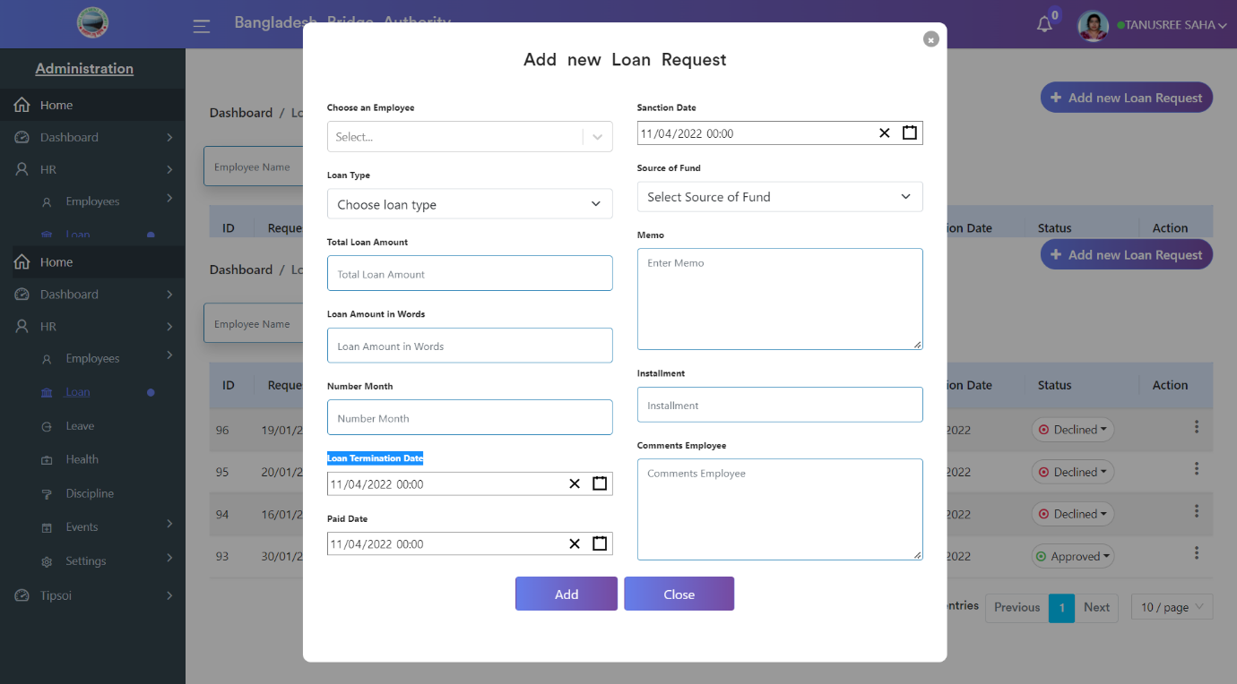

**Administration >** **Human Resource > HR > Leave**

Here the leave page deals with employee leaves and related activities.

Use the Employees > Leave > Employee Leave Request for leave to see the list view of the Leave requests.

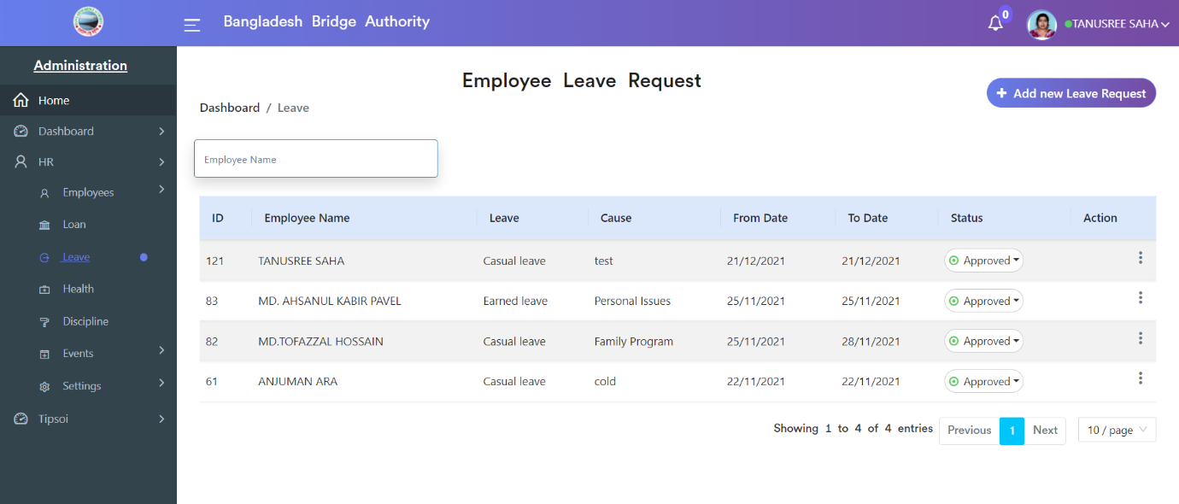

>> Click on the ‘Add new Leave Request’ button to create a Leave request. Select the employee and fill in other details such as the From Date, To Date, Name of Leave, Cause, etc. Then we can submit the request and wait for the approval.

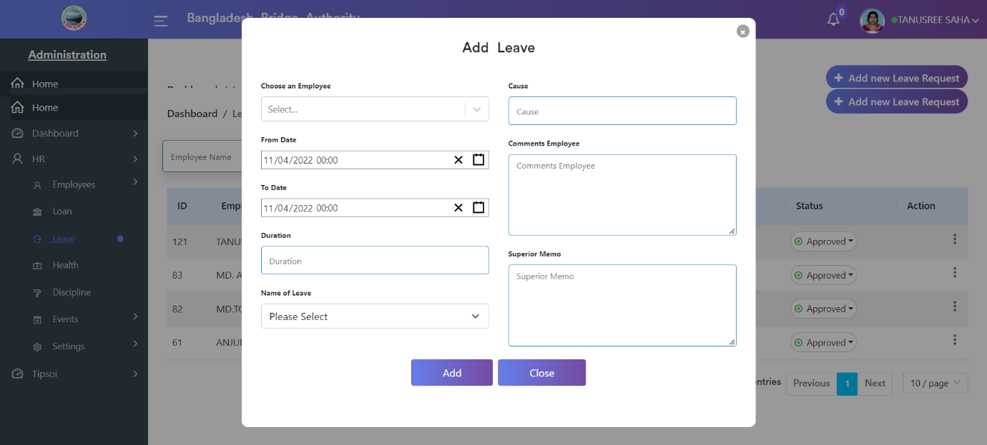

**Administration >** **Human Resource > HR > Health**

This page shows employees’ health records and related activities.

Use the Employees > health > Health Records for health to see the list view of the health records.

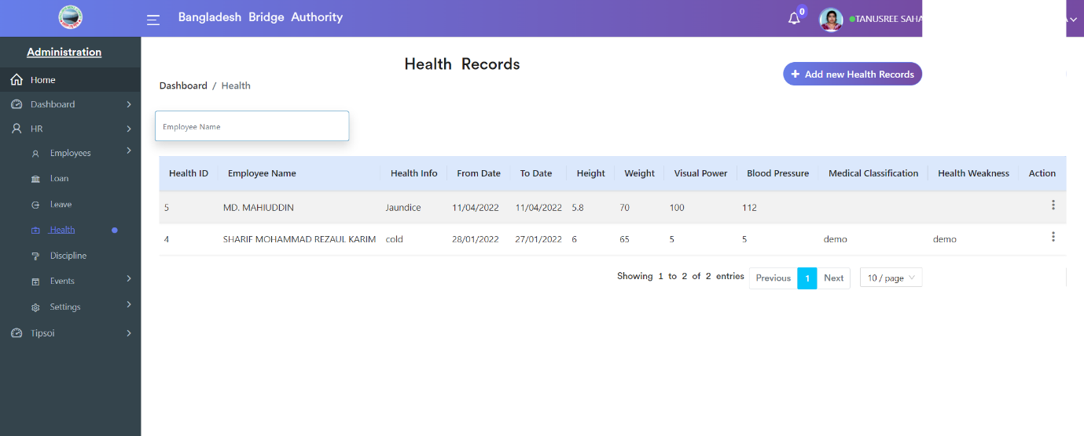

>> Click on the ‘Add new Health Records’ button to create a Health record. Select the employee and fill in other details such as the Weight, Height, Visual Power, X-ray Report, ECG Report, Blood Pressure, etc. Then we can submit the record.

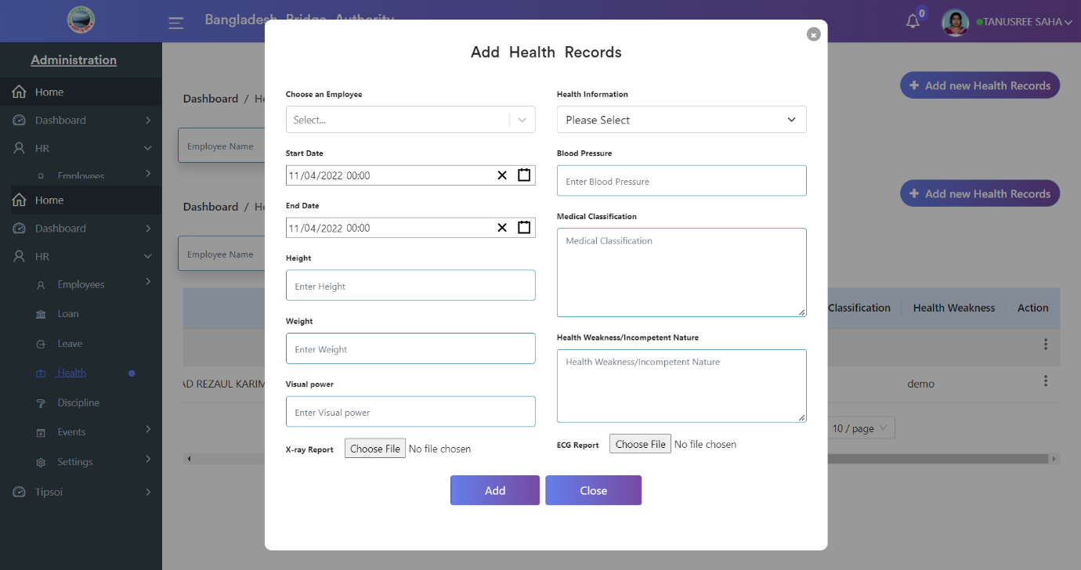

**Administration >** **Human Resource > HR > Discipline**

This page shows employees’ punishment records and related activities.

Use the Employees > health > Disciplines for punishment to see the list view of the punishment records.

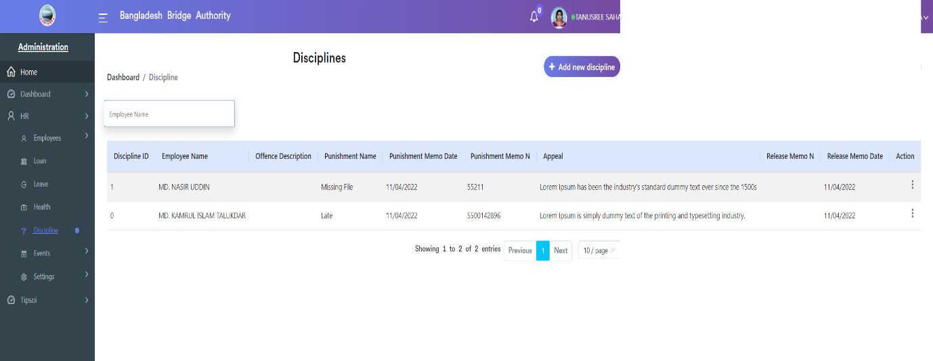

>> Click on the ‘Add new Discipline’ button to create an employee’s Punishment record. Select the employee and fill in other details such as the Name of Punishment, Punishment Memo No, Description of Offence, Type of Punishment, Appeal, etc. Then we can submit the record.

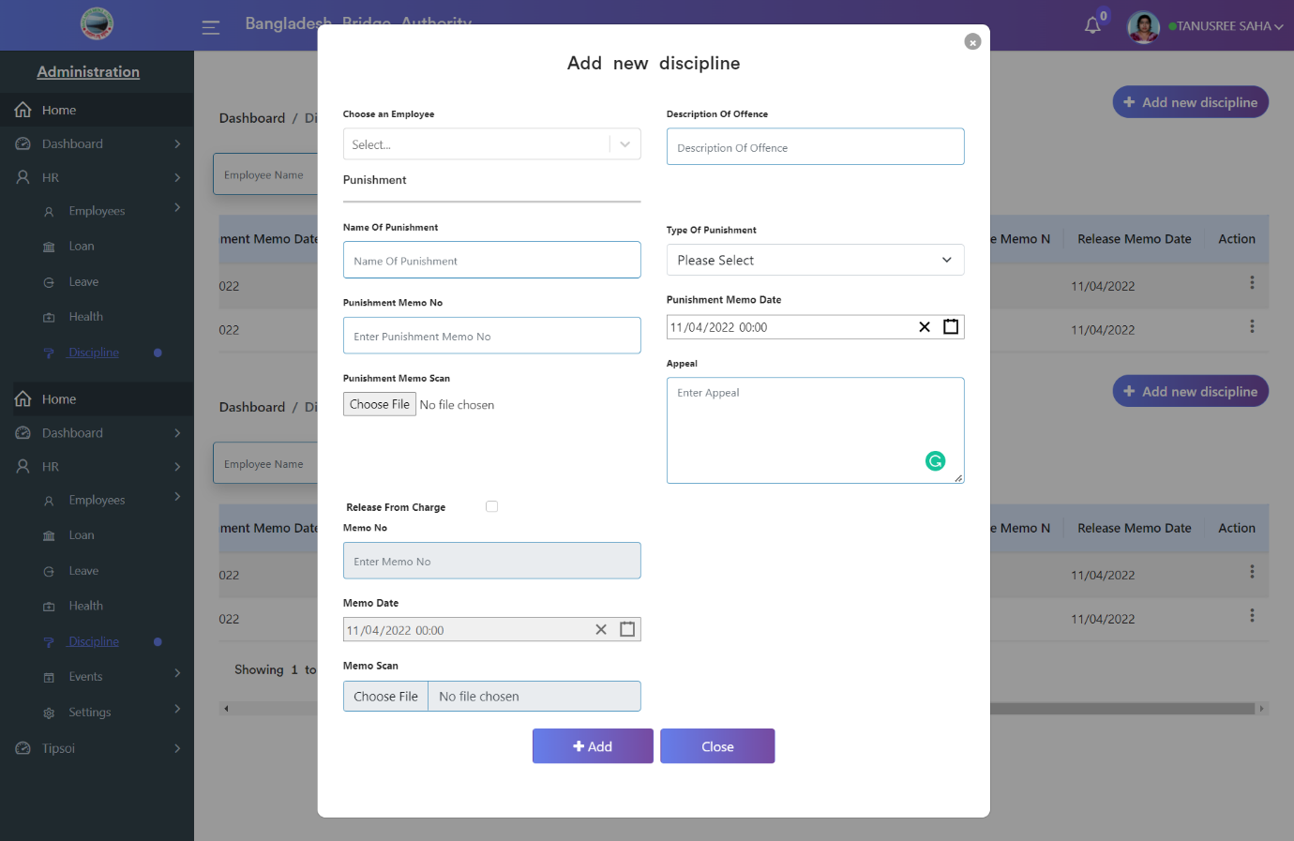

**Administration >** **Human Resource > HR > Events**

After Clicking on Events there has 3 sub-menus. These are-

1. Dashboard
2. Calendar
3. Event

**1. Dashboard:** After clicking on **Administration > Human Resource > HR > Events > Dashboard**. The event dashboard gives details about the employee’s events in the BBA and also about all of the event’s information at a glance.

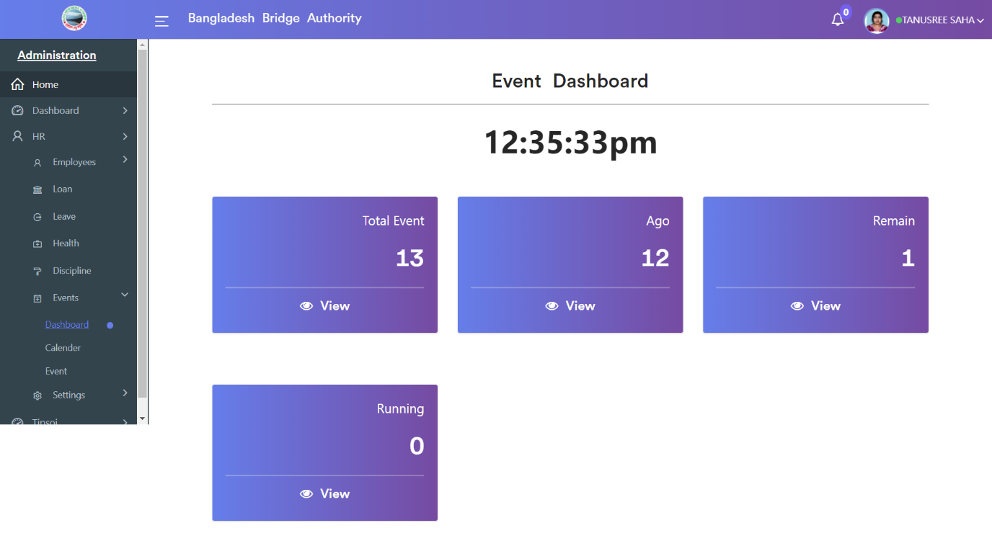

**2. Calendar:** After clicking on **Administration > Human Resource > HR > Events > Calendar**.  It allows you to have a detailed in-hand calendar which can be of great usage for events. The calendar can be viewed as a day, week, or month. The events we added will be visible in all calendars whether it is day, week, or month.

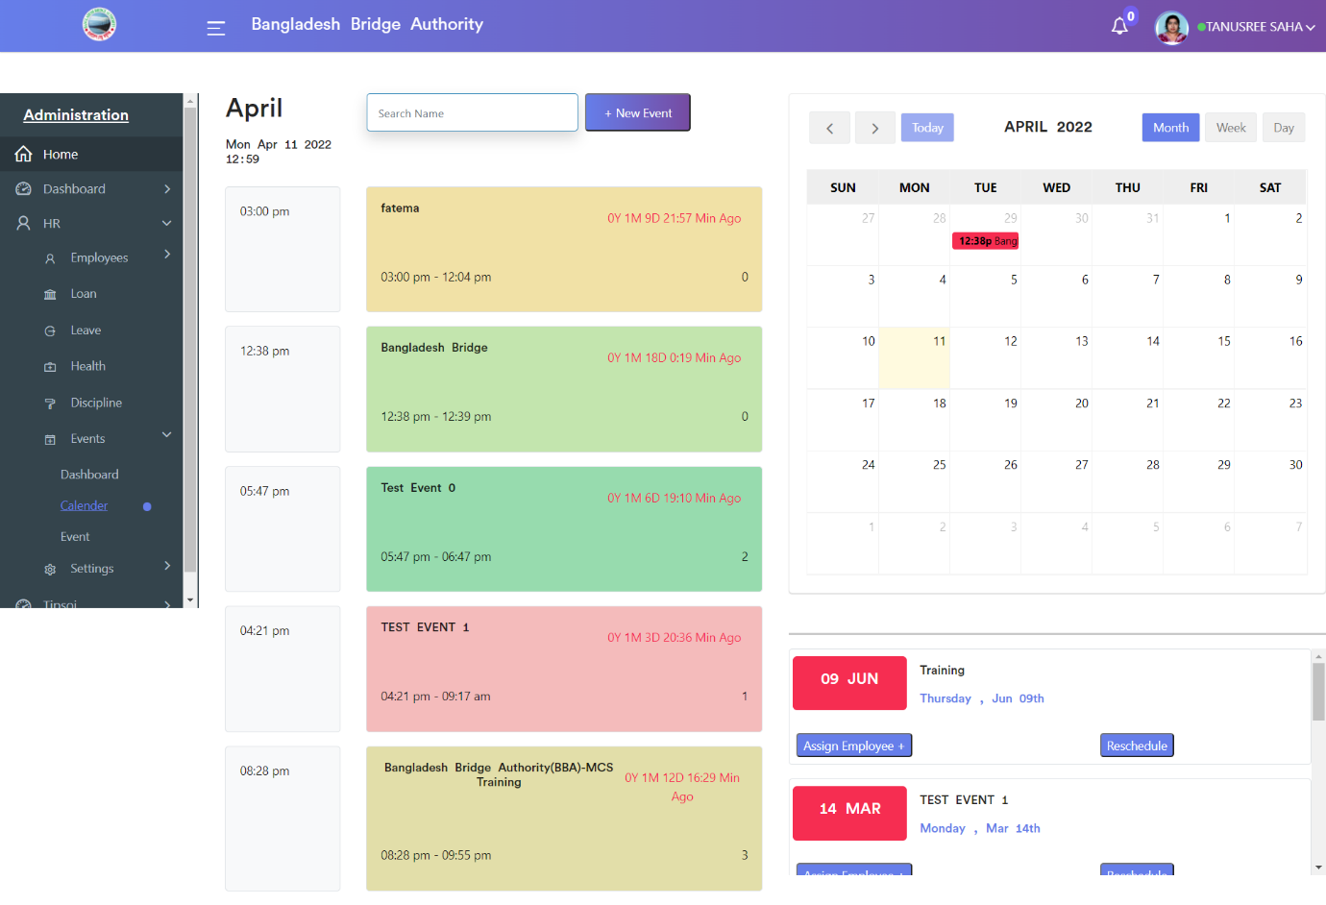

**3.Event:** Clicking on **Administration > Human Resource > HR > Events > Event**. This page shows employees’ events records. Here we can see the list view of the events records. In the action tab using ‘Assign Employee’ link we can add event employees.

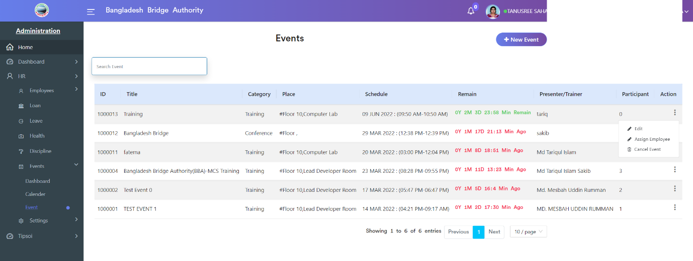

>> Click on the ‘New Event’ button to create an employee’s event record. Fill in the details information such as the Event Title, Event Category, Department, Presenter/Trainer, Start Date, etc. Then we can save the record.

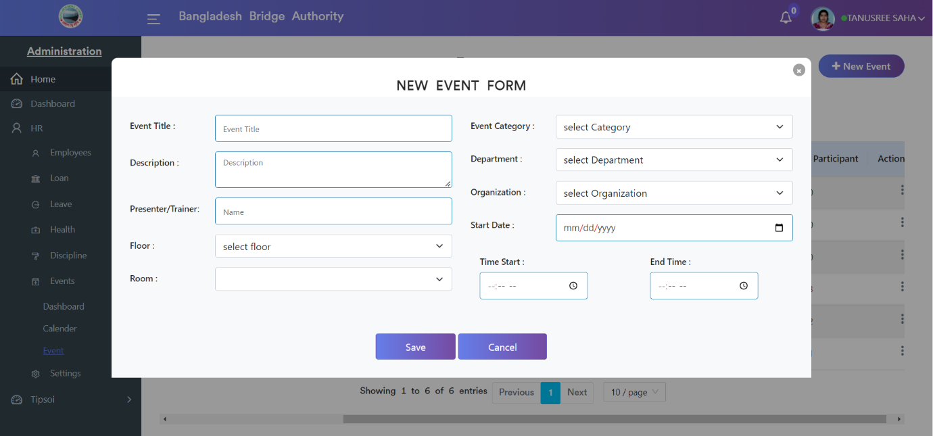

**Administration >** **Human Resource > HR > Settings**

Open the ‘Settings’ application for configuring various settings of the Human Resource.

There have several options. Such as-

1. Roles & Permissions
2. Users
3. Loan Types
4. Document Type
5. Health Information
6. Punishment
7. Departments
8. Designation
9. District
10. Loan Funds
11. Leave Types
12. Grades
13. ACRClass
14. ACRTypes

**1. Roles & Permissions: From Roles**